**Conclusion**

During this project phase we found many conclusions and all of them are listed below:

1. 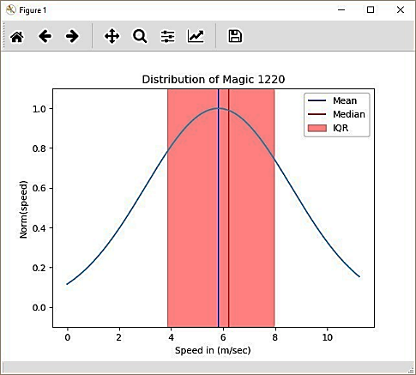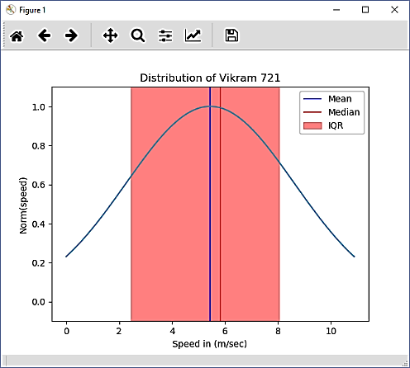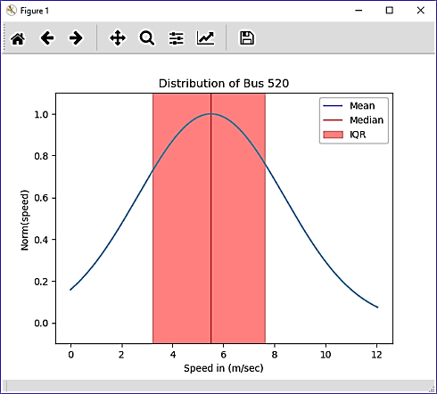The distribution of speed is very similar in all of the four wheelers among themselves while all of the two wheelers reflects the same distribution.

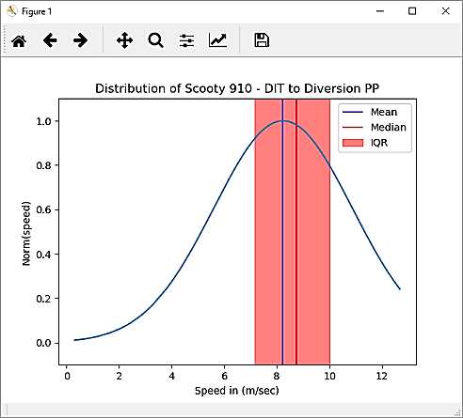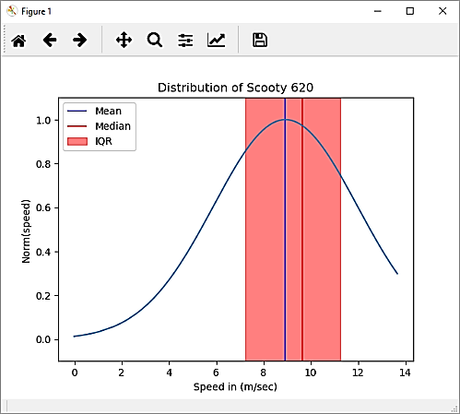

1. The speed is necessary but not sufficient for the identification of the transport mode, we need multiple features for the correct identification of transport mode detection. As the decision boundary that separates two different classes of transport mode is not very crisp and hence speed is not sufficient.
2. The speed of transport mode depends on location as heavily populated places tend to have lower speed thresholds as compared to less populated areas. Road networks with narrower road, heavy traffic or sharp turns generally have less average speed as compared to their counterparts.
3. The speed of transport also depends on the time of transit, as times of Office hours, or school hours, etc. starts or ends is much slower than other times as congestion increases.
4. For Mahalanobis Distance :

de(t) = NaN: -

When both samples are identical in nature thus we simply slide the window without saving anchor.

de(t) = Inf: -

When both samples are not identical and one sample has an identical set of data that means variance is zero so, that will result in infinity.